SOFTWARE ANALYSIS MODELS
Safehome project by CPI corporation

March 05, 2015
Version 1.0

Chung Saehun
Koo Yoonpyo

TABLE OF CONTENTS
1. Introduction 4
2. Use case diagram 4
2.1. Use case diagram for security feature 4
2.2. Use case diagram for surveillance feature 5
2.3. Use case diagram for Safehome Website 6
3. Use case 7
3.1. Use cases for security feature 7
3.1.1. Set security zone 7
3.1.2. Check sensor status 8
3.1.3. Initialize a sensor 9
3.1.4. Finish a sensor 9
3.1.5. Arm a sensor 10
3.1.6. Disarm a sensor 11
3.1.7. Arm a security zone 11
3.1.8. Disarm a security zone 12
3.1.9. Monitor sensors 13
3.1.10. Emergency alarm 13
3.2. Use cases for surveillance feature 14
3.2.1. View thumbnails 14
3.2.2. View a single camera 15
3.2.3. Start recording a video 15
3.2.4. Stop recording a video 16
3.2.5. Replay a video 17
3.2.6. Download a video 17
3.2.7. Pan a camera 18
3.2.8. Zoom a camera 19
3.3. Use cases for Safehome Website 19
3.3.1. Make an Safehome Website account 19
3.3.2. Log in to Safehome Website 20
3.3.3. Prevent unauthorized login attempt 21
3.3.4. Change password 21
3.3.5. Prevent multiple concurrent Safehome Website access 22
3.4. Use cases for Safehome system management 23
3.4.1. Initial Safehome system setting 23
3.4.2. Safehome system maintenance 23
3.4.3. Add a device into Safehome system 24
4. Swimlane diagram 25
4.1. Swimlane diagram for security feature 25
4.1.1. Set security zone (UC1) 25
4.1.2. Check sensor status (UC2) 26
4.1.3. Initialize/finish sensor (UC3, UC4) 27
4.1.4. Arm/disarm sensor (UC5, UC6) 28
4.1.5. Arm/disarm security zone (UC7, UC8) 29
4.1.6. Monitor sensors (UC9) 30
4.1.7. Emergency alarm (UC10) 31
4.2. Swimlane diagram for surveillance feature 31
4.2.1. View thumbnails (UC11), View a single camera (UC12), start/stop recording (UC13, UC14), pan/zoom camera (UC17, UC18) 31
4.2.2. Replay/download video (UC15, UC16) 33
4.3. Swimlane diagram for Safehome Website 34
4.3.1. Make an account (UC19) 34
4.3.2. Log in to Safehome Website (UC20) 35
4.3.3. Change password (UC21) 36
5. Appendix 37
5.1. Meeting log 37
5.2. Who did what list 39

Introduction
This document describes analysis model of Safehome project. The analysis model comprises of use case diagram, use case, and swimlane diagram. To help comprehension, reading glossary in SRS document first is recommended.

Use case diagram

Use case diagram for security feature
Figure 1 Use case diagram for security feature

Use case diagram for surveillance feature
Figure 2 Use case diagram for surveillance feature

Use case diagram for Safehome Website
Figure 3 Use case diagram for Safehome Website

Use case

Use cases for security feature

Set security zone
Use Case Code | UC1
Use Case Name | Set security zone
Related Requirements | FR1.1
Created By | Koo Yoonpyo | Last Modified By | Koo Yoonpyo
Created At | May 5th 2015 | Last Modified At | May 5th 2015

Primary actor | User
Goal in context | User sets security zone which comprise any set of sensors and cameras.
Preconditions | 1. Safehome system is installed in user’s home.
Trigger | User decides to set a security zone.
Scenario | 1. User logs in to Safehome Website.  2. User selects ‘security zone’ menu.  3. User clicks ‘set a new security zone’ button.  4. User enters password one more time.  5. User selects sensors and cameras that user wants.  6. User Click ‘complete’ button.
Exceptions | N/A
Priority | High
Frequency of use | Low
Channel to actor | Safehome Website

Check sensor status
Use Case Code | UC2
Use Case Name | Check sensor status
Related Requirements | FR1.2
Created By | Koo Yoonpyo | Last Modified By | Koo Yoonpyo
Created At | May 5th 2015 | Last Modified At | May 5th 2015

Primary actor | User
Goal in context | User checks sensor status.
Preconditions | 1. Safehome system is installed in user’s home.
Trigger | User decides to check sensor status.
Scenario | 1. User logs in to Safehome Website.  2. User selects ‘floor plan’ menu.  3. User can check sensor status from the floor plan.
Exceptions | N/A
Priority | High
Frequency of use | Medium
Channel to actor | Safehome Website

Initialize a sensor
Use Case Code | UC3
Use Case Name | Initialize a sensor
Related Requirements | FR1.3
Created By | Koo Yoonpyo | Last Modified By | Koo Yoonpyo
Created At | May 5th 2015 | Last Modified At | May 5th 2015

Primary actor | User
Goal in context | User initializes sensor that user wants.
Preconditions | 1. Safehome system is installed in user’s home.  2. A sensor that user wants to initialize should not be already initialized.
Trigger | User decides to initialize sensor.
Scenario | 1. User logs in to Safehome Website.  2. User selects ‘floor plan’ menu.  3. User clicks a sensor icon placed in floor plan  4. User clicks ‘initialze’ button.  5. User enters password one more time.  6. Selected sensor is initialized.
Exceptions | 1. If entered password in step 5 in scenario is wrong, sensor will not be initiated.
Priority | High
Frequency of use | Low
Channel to actor | Safehome Website

Finish a sensor
Use Case Code | UC4
Use Case Name | Finish a sensor
Related Requirements | FR1.4
Created By | Koo Yoonpyo | Last Modified By | Koo Yoonpyo
Created At | May 5th 2015 | Last Modified At | May 5th 2015

Primary actor | User
Goal in context | User finishes a sensor.
Preconditions | 1. Safehome system is installed in user’s home.  2. A sensor that user wants to finish should be already initialized.
Trigger | User decides to finish a sensor.
Scenario | 1. User logs in to Safehome Website.  2. User selects ‘floor plan’ menu.  3. User clicks a sensor icon placed in floor plan.  4. User clicks ‘finish’ button.  5. User enters password one more time.  6. Selected sensor is finished.
Exceptions | 1. If entered password in step 5 in scenario is wrong, sensor will not be finished.
Priority | High
Frequency of use | Low
Channel to actor | Safehome Website

Arm a sensor
Use Case Code | UC5
Use Case Name | Arm a sensor
Related Requirements | FR1.5
Created By | Koo Yoonpyo | Last Modified By | Koo Yoonpyo
Created At | May 5th 2015 | Last Modified At | May 5th 2015

Primary actor | User
Goal in context | User arms a sensor.
Preconditions | 1. Safehome system is installed in user’s home.  2. A sensor that user wants to arm should be already initialized.
Trigger | User decides to arm a sensor.
Scenario | 1. User logs in to Safehome Website.  2. User selects ‘floor plan’ menu.  3. User clicks a sensor icon placed in floor plan.  4. User clicks ‘arm’ button.  5. User enters password one more time.  6. Selected sensor is armed.
Exceptions | 1. If entered password in step 5 in scenario is wrong, sensor will not be finished.
Priority | High
Frequency of use | Medium
Channel to actor | Safehome Website

Disarm a sensor
Use Case Code | UC6
Use Case Name | Disarm a sensor
Related Requirements | FR1.6
Created By | Koo Yoonpyo | Last Modified By | Koo Yoonpyo
Created At | May 5th 2015 | Last Modified At | May 5th 2015

Primary actor | User
Goal in context | User disarms a sensor.
Preconditions | 1. Safehome system is installed in user’s home.  2. A sensor that user wants to disarm should be already armed.
Trigger | User decides to disarm a sensor.
Scenario | 1. User logs in to Safehome Website.  2. User selects ‘floor plan’ menu.  3. User clicks sensor icon placed in floor plan.  4. User clicks ‘disarm’ button.  5. User enters password one more time.  6. Selected sensor is disarmed.
Exceptions | 1. If entered password in step 5 in scenario is wrong, sensor will not be finished.
Priority | High
Frequency of use | Medium
Channel to actor | Safehome Website

Arm a security zone
Use Case Code | UC7
Use Case Name | Arm a security zone
Related Requirements | FR1.1
Created By | Koo Yoonpyo | Last Modified By | Koo Yoonpyo
Created At | May 5th 2015 | Last Modified At | May 5th 2015

Primary actor | User
Goal in context | User sets security zone which comprise any set of sensors and cameras.
Preconditions | 1. Safehome system is installed in user’s home.  2. Selected security zone is already disarmed.
Trigger | User decides to set a security zone.
Scenario | 1. User logs in to Safehome Website.  2. User selects ‘security zone’ menu.  3. A list of security zones show up  4. User selects one of the security zone in the list.  5. User clicks ‘arm’ button  6. User enters password one more time.  7. Selected security zone is armed.
Exceptions | N/A
Priority | High
Frequency of use | Medium
Channel to actor | Safehome Website

Disarm a security zone
Use Case Code | UC8
Use Case Name | Disarm a security zone
Related Requirements | FR1.1
Created By | Koo Yoonpyo | Last Modified By | Koo Yoonpyo
Created At | May 5th 2015 | Last Modified At | May 5th 2015

Primary actor | User
Goal in context | User sets security zone which comprise any set of sensors and cameras.
Preconditions | 1. Safehome system is installed in user’s home.  2. Selected security zone is already armed.
Trigger | User decides to set a security zone.
Scenario | 1. User logs in to Safehome Website.  2. User selects ‘security zone’ menu.  3. A list of security zones show up  4. User selects one of the security zone in the list.  5. User clicks ‘disarm’ button  6. User enters password one more time.  7. Selected security zone is disarmed.
Exceptions | N/A
Priority | High
Frequency of use | Medium
Channel to actor | Safehome Website

Monitor sensors
Use Case Code | UC9
Use Case Name | Monitor sensors
Related Requirements | FR1.8
Created By | Koo Yoonpyo | Last Modified By | Koo Yoonpyo
Created At | May 5th 2015 | Last Modified At | May 5th 2015

Primary actor | User
Goal in context | User monitors sensors.
Preconditions | 1. Safehome system is installed in user’s home.  2. Sensors should be already initiated.
Trigger | User decides to monitor sensors.
Scenario | 1. User logs in to Safehome Website.  2. User selects ‘floor plan’ menu.  3. User monitors sensors.
Exceptions | N/A
Priority | High
Frequency of use | Medium
Channel to actor | Safehome Website

Emergency alarm
Use Case Code | UC10
Use Case Name | Emergency alarm
Related Requirements | FR1.9
Created By | Koo Yoonpyo | Last Modified By | Koo Yoonpyo
Created At | May 5th 2015 | Last Modified At | May 5th 2015

Primary actor | Safehome system
Goal in context | Safehome system alarms users when emergency happens.
Preconditions | 1. Safehome system is installed in user’s home.  2. User already registered his/her phone number to Safehome system.
Trigger | A sensor senses emergency.
Scenario | 1. A sensor senses emergency.  2. Safehome system sends a SMS message describing emergency situation.  3. If user specified any other alarm methods, alarm messages will be sent using those methods.
Exceptions | 1. If user’s phone is unavailable, SMS message can’t be sent.
Priority | Very high
Frequency of use | Medium
Channel to actor | Safehome system central processor

Use cases for surveillance feature

View thumbnails
Use Case Code | UC11
Use Case Name | View thumbnails
Related Requirements | FR2.1
Created By | Koo Yoonpyo | Last Modified By | Koo Yoonpyo
Created At | May 5th 2015 | Last Modified At | May 5th 2015

Primary actor | User
Goal in context | User views thumbnails of each camera.
Preconditions | 1. Safehome system is installed in user’s home.
Trigger | User decides to view thunbnails of each camera
Scenario | 1. User logs in to Safehome Website.  2. User selects ‘floor plan’ menu.  3. User views thumbnails of each camera.
Exceptions | N/A
Priority | High
Frequency of use | High
Channel to actor | Safehome Website

View a single camera
Use Case Code | UC12
Use Case Name | View a single camera
Related Requirements | FR2.2
Created By | Koo Yoonpyo | Last Modified By | Koo Yoonpyo
Created At | May 5th 2015 | Last Modified At | May 5th 2015

Primary actor | User
Goal in context | User views a single camera output.
Preconditions | 1. Safehome system is installed in user’s home.
Trigger | User decides to view a single camera output.
Scenario | 1. User logs in to Safehome Website.  2. User selects ‘floor plan’ menu.  3. User clicks a thumbnail view of a camera that user wants to watch.  4. User views a single camera output.
Exceptions | N/A
Priority | High
Frequency of use | High
Channel to actor | Safehome Website

Start recording a video
Use Case Code | UC13
Use Case Name | Start recording a video
Related Requirements | FR2.3
Created By | Koo Yoonpyo | Last Modified By | Koo Yoonpyo
Created At | May 5th 2015 | Last Modified At | May 5th 2015

Primary actor | User
Goal in context | User starts recording a video of a camera.
Preconditions | 1. Safehome system is installed in user’s home.
Trigger | User decides to record a video of a camera.
Scenario | 1. User logs in to Safehome Website.  2. User selects ‘floor plan’ menu.  3. User clicks a thumbnail view of a camera that user wants to record.  4. User can specify recording period(e.g., 1 hour) using ‘recording time’ button next to ‘start recording’ button.  5 If user doesn’t specify recording time, recording doesn’t stop until user explicitly stops it.  6. User clicks ‘start recording’ button.  7. User enters password one more time.  8. Recording starts.
Exceptions | N/A
Priority | High
Frequency of use | Medium
Channel to actor | Safehome Website

Stop recording a video
Use Case Code | UC14
Use Case Name | Stop recording a video
Related Requirements | FR2.3
Created By | Koo Yoonpyo | Last Modified By | Koo Yoonpyo
Created At | May 5th 2015 | Last Modified At | May 5th 2015

Primary actor | User
Goal in context | User stops recording a video of a camera.
Preconditions | 1. Safehome system is installed in user’s home.  2. User should already start recording a video that user wants to stop recording.
Trigger | User decides to stop recording a video.
Scenario | 1. User logs in to Safehome Website.  2. User selects ‘floor plan’ menu.  3. User clicks a thumbnail view of a camera that user wants to stop recording.  4. User clicks ‘stop recording’ button.  5. User enters password one more time.  6. Recording stops.
Exceptions | N/A
Priority | High
Frequency of use | High
Channel to actor | Safehome Website

Replay a video
Use Case Code | UC15
Use Case Name | Replay a video
Related Requirements | FR2.4
Created By | Koo Yoonpyo | Last Modified By | Koo Yoonpyo
Created At | May 5th 2015 | Last Modified At | May 5th 2015

Primary actor | User
Goal in context | User replays a video recorded.
Preconditions | 1. Safehome system is installed in user’s home.  2. Video that user wants to replay should have been already recorded.
Trigger | User decides to replay a video.
Scenario | 1. User logs in to Safehome Website.  2. User selects ‘recorded videos’ menu.  3. A list of recorded video shows up.  4. User select a video that user wants to watch.  5. Click ‘replay’ button.  6. Replay starts.
Exceptions | N/A
Priority | High
Frequency of use | High
Channel to actor | Safehome Website

Download a video
Use Case Code | UC16
Use Case Name | Download a video
Related Requirements | FR2.5
Created By | Koo Yoonpyo | Last Modified By | Koo Yoonpyo
Created At | May 5th 2015 | Last Modified At | May 5th 2015

Primary actor | User
Goal in context | User downloads a video from Safehome Web server.
Preconditions | 1. Safehome system is installed in user’s home.  2. Video that user wants to download should have been already recorded.
Trigger | User decides to download a video.
Scenario | 1. User logs in to Safehome Website.  2. User selects ‘recorded videos’ menu.  3. A list of recorded video shows up.  4. User select a video that user wants to download.  5. Click ‘download’ button.  6. Download starts.
Exceptions | N/A
Priority | High
Frequency of use | High
Channel to actor | Safehome Website

Pan a camera
Use Case Code | UC17
Use Case Name | Pan a camera
Related Requirements | FR2.6
Created By | Koo Yoonpyo | Last Modified By | Koo Yoonpyo
Created At | May 5th 2015 | Last Modified At | May 5th 2015

Primary actor | User
Goal in context | User pans a camera.
Preconditions | 1. Safehome system is installed in user’s home.
Trigger | User decides to pan a camera.
Scenario | 1. User logs in to Safehome Website.  2. User selects ‘floor plan’ menu.  3. User clicks a thumbnail of camera that user wants to pan.  4. User clicks ‘control camera’ button.  5. User enters password one more time.  6. User pans a camera.
Exceptions | N/A
Priority | High
Frequency of use | Medium
Channel to actor | Safehome Website

Zoom a camera
Use Case Code | UC18
Use Case Name | Zoom a camera
Related Requirements | FR2.7
Created By | Koo Yoonpyo | Last Modified By | Koo Yoonpyo
Created At | May 5th 2015 | Last Modified At | May 5th 2015

Primary actor | User
Goal in context | User zooms a camera.
Preconditions | 1. Safehome system is installed in user’s home.
Trigger | User decides to zoom a camera.
Scenario | 1. User logs in to Safehome Website.  2. User selects ‘floor plan’ menu.  3. User clicks a thumbnail of camera that user wants to pan.  4. User clicks ‘control camera’ button.  5. User enters password one more time.  6. User zooms a camera.
Exceptions | N/A
Priority | High
Frequency of use | Medium
Channel to actor | Safehome Website

Use cases for Safehome Website

Make an Safehome Website account
Use Case Code | UC19
Use Case Name | Make an Safehome Website account
Related Requirements | FR3.1
Created By | Koo Yoonpyo | Last Modified By | Koo Yoonpyo
Created At | May 5th 2015 | Last Modified At | May 5th 2015

Primary actor | User
Goal in context | User makes an account for accessing Safehome system.
Preconditions | 1. User purchased Safehome system.  2. User has a registration key which CPI Corporation gave when user purchased Safehome system.
Trigger | User purchases Safehome system.
Scenario | 1. User visits Safehome Website.  2. From the main page, user clicks ‘register’ button.  3. User enters user ID in ‘user id’ form.  4. User enters password in ‘password’ form.  5. User enters password again in ‘confirm password’ form.  6. User enters registration key in ‘registration key’ form.  7. User clicks ‘register’ button.
Exceptions | 1. If user enters different password in ‘password’ form and ‘confirm password’, registration will fails.  2. If user enters a registration key which doesn’t exist, registration will fail.
Priority | High
Frequency of use | Low
Channel to actor | Safehome Website

Log in to Safehome Website
Use Case Code | UC20
Use Case Name | Log in to Safehome Website
Related Requirements | FR3.2
Created By | Koo Yoonpyo | Last Modified By | Koo Yoonpyo
Created At | May 5th 2015 | Last Modified At | May 5th 2015

Primary actor | User
Goal in context | User logs in to Safehome Website.
Preconditions | 1. User should already have a Safehome Website account.
Trigger | User decides to log in to Safehome Website.
Scenario | 1. User visits Safehome Website.  2. From the main page, user enters his/her user ID in ‘ID’ form.  3. User enters password in ‘password’ form.  4. User clicks ‘log in’ button.
Exceptions | If user enters wrong user ID and password pair, log in fails.
Priority | High
Frequency of use | High
Channel to actor | Safehome Website

Prevent unauthorized login attempt
Use Case Code | UC20
Use Case Name | Prevent unauthorized login attempt
Related Requirements | FR3.3
Created By | Koo Yoonpyo | Last Modified By | Koo Yoonpyo
Created At | May 5th 2015 | Last Modified At | May 5th 2015

Primary actor | Safehome system
Goal in context | Prevent unauthorized log in attempt.
Preconditions | User should already have a Safehome Website account.
Trigger | Unauthorized person decides to log in to Safehome Website with other’s user ID.
Scenario | 1. A person(could be user, or any other person) attempts to log in Safehome Website.  2. Log in attempts failed in 5 consecutive times.  3. The account that person tried to log in will be disabled by Safehome system.
Exceptions | N/A
Priority | High
Frequency of use | Low
Channel to actor | Safehome Website

Change password
Use Case Code | UC21
Use Case Name | Change password
Related Requirements | FR3.4
Created By | Koo Yoonpyo | Last Modified By | Koo Yoonpyo
Created At | May 5th 2015 | Last Modified At | May 5th 2015

Primary actor | User
Goal in context | User changes password.
Preconditions | 1. User should already have a Safehome Website account.
Trigger | User decides to change his/her Safehome Website account’s password.
Scenario | 1. User logs in to Safehome Website.  2. User selects ‘my account’ menu.  3. User click ‘change password’ button.  4. User enters current password in ‘current password’ form.  5. User enters new password in ‘new password’ form.  6. User enters new password again in ‘confirm new password’ form.  7. User clicks ‘complete’ button.
Exceptions | 1. If user enters wrong current password, changing password will fail.  2. If user enters different password in ‘new password’ form and ‘confirm new password’ form, changing password will fail.
Priority | High
Frequency of use | Low
Channel to actor | Safehome Website

Prevent multiple concurrent Safehome Website access
Use Case Code | UC22
Use Case Name | Prevent multiple concurrent Safehome Website access
Related Requirements | FR3.5
Created By | Koo Yoonpyo | Last Modified By | Koo Yoonpyo
Created At | May 5th 2015 | Last Modified At | May 5th 2015

Primary actor | Safehome system
Goal in context | Prevent multiple concurrent Safehome Website access.
Preconditions | 1. User should already have a Safehome Website account.
Trigger | A person tries to log in to Safehome Website with an account while that account is already logged in and keeping its session.
Scenario | 1. User logs in to Safehome Website.  2. A person(could be anyone including the user himself/herself) tries to log in to Safehome Website with same account that user used in step 1.  3. Log in attempts in step 2 will be discarded.
Exceptions
Priority | Medium
Frequency of use | Low
Channel to actor | Safehome Website

Use cases for Safehome system management

Initial Safehome system setting
Use Case Code | UC23
Use Case Name | Initial Safehome system setting
Related Requirements | FR4.1
Created By | Koo Yoonpyo | Last Modified By | Koo Yoonpyo
Created At | May 5th 2015 | Last Modified At | May 5th 2015

Primary actor | Safehome system provider
Goal in context | Safehome system provider sets the initial safehome system.
Preconditions | 1. User purchases Safehome system.
Trigger | User purchases Safehome system.
Scenario | 1. Safehome system provider and user discuss what to deploy, and where to deploy sensors and cameras.  2. Safehome system provider visits user’s house and installs each sensors and cameras.
Exceptions | N/A
Priority | High
Frequency of use | Low

Safehome system maintenance
Use Case Code | UC24
Use Case Name | System maintenance
Related Requirements | FR4.2
Created By | Koo Yoonpyo | Last Modified By | Koo Yoonpyo
Created At | May 5th 2015 | Last Modified At | May 5th 2015

Primary actor | Safehome system provider
Goal in context | Safehome system provider provides 2-year free warranty for device(e.g., sensor, camera, etc) disorder. After 2 years, customer should pay for maintenance service.
Preconditions | 1. Safehome system is installed in user’s home.
Trigger | A device is broken.
Scenario | 1. User calls to Safehome system provider.  2. User describes which sensor is broken.  3. Safehome system provider visits user’s home in 3 days, and fix the broken device.
Exceptions | N/A
Priority | High
Frequency of use | Low

Add a device into Safehome system
Use Case Code | UC25
Use Case Name | Add a device into safehome system
Related Requirements | FR4.3
Created By | Koo Yoonpyo | Last Modified By | Koo Yoonpyo
Created At | May 5th 2015 | Last Modified At | May 5th 2015

Primary actor | Safehome system provider
Goal in context | Add a device into Safehome system
Preconditions | 1. Safehome system is installed in user’s home
Trigger | User decides to install additional device into Safehome system.
Scenario | 1. User calls to Safehome system provider.  2. User describes which device user wants to add.  3. Safehome system provider visits user’s house in 3 days and install additional device.
Exceptions | N/A
Priority | Medium
Frequency of use | Low

Swimlane diagram

Swimlane diagram for security feature

Set security zone (UC1)
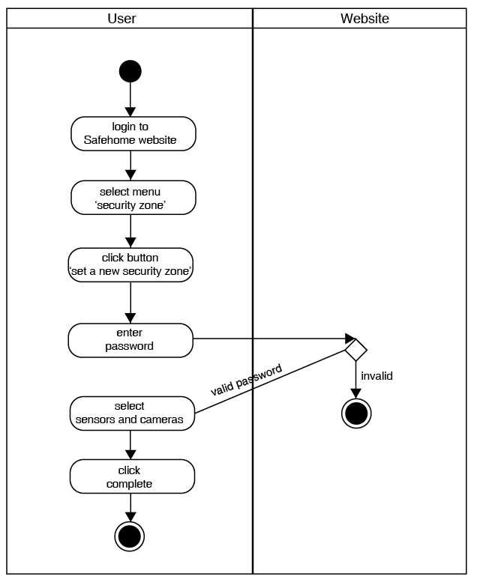
Figure 4 Swimlane diagram for Set security zone

Check sensor status (UC2)
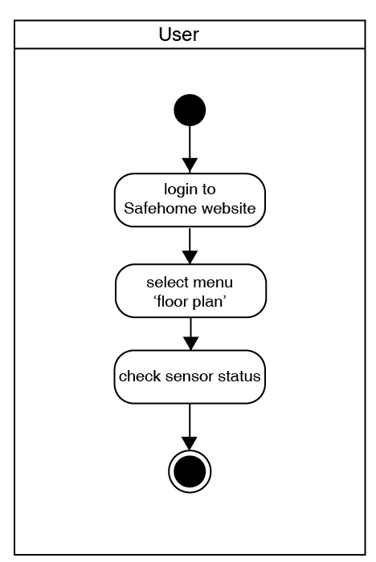
Figure 5 Swimlane diagram for Check sensor status

Initialize/finish sensor (UC3, UC4)
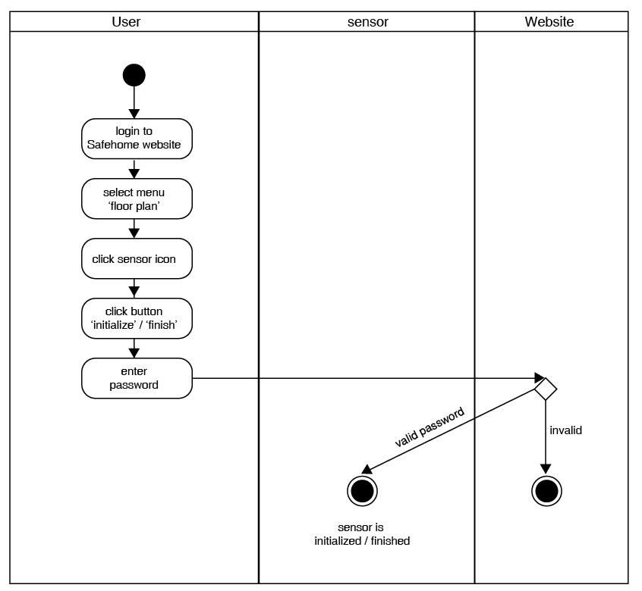
Figure 6 Swimlane diagram for Initialize/finish sensor

Arm/disarm sensor (UC5, UC6)
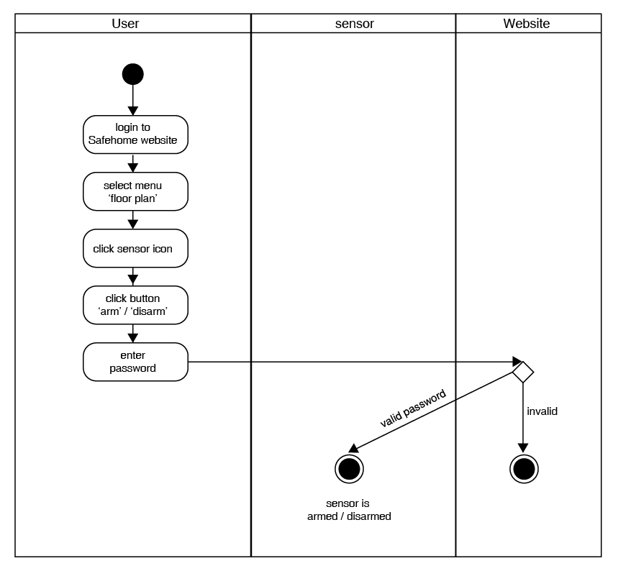
Figure 7 Swimlane diagram for Arm/diarm sensor

Arm/disarm security zone (UC7, UC8)
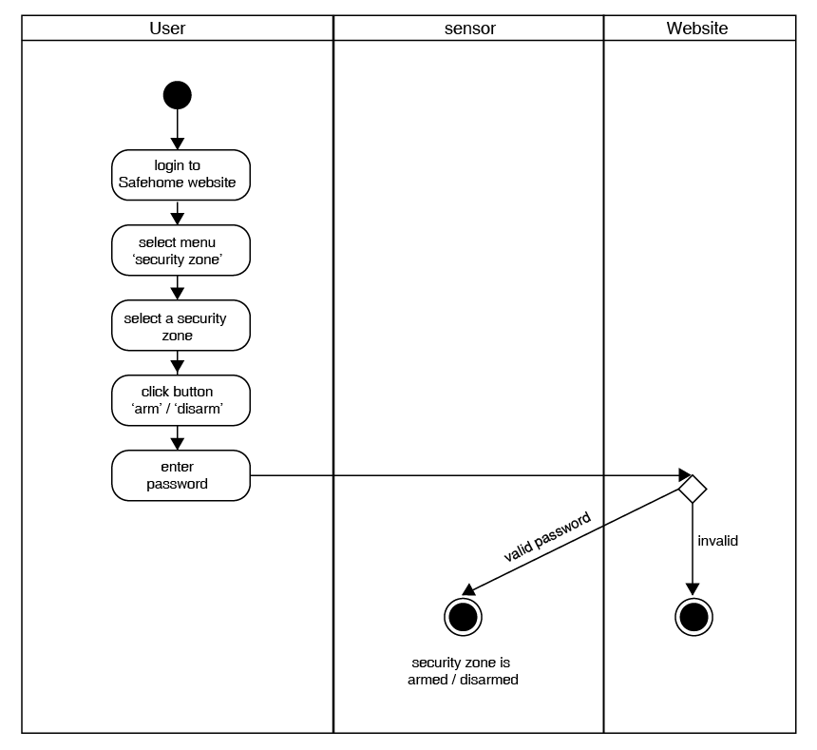
Figure 8 Swimlane diagram for Arm/disarm security zone

Monitor sensors (UC9)
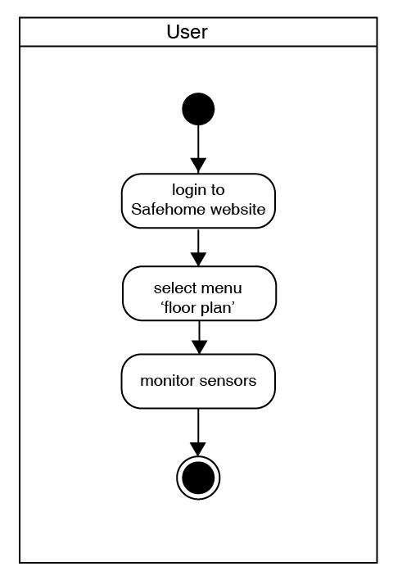
Figure 9 Swimlane diagram for Monitor sensors

Emergency alarm (UC10)
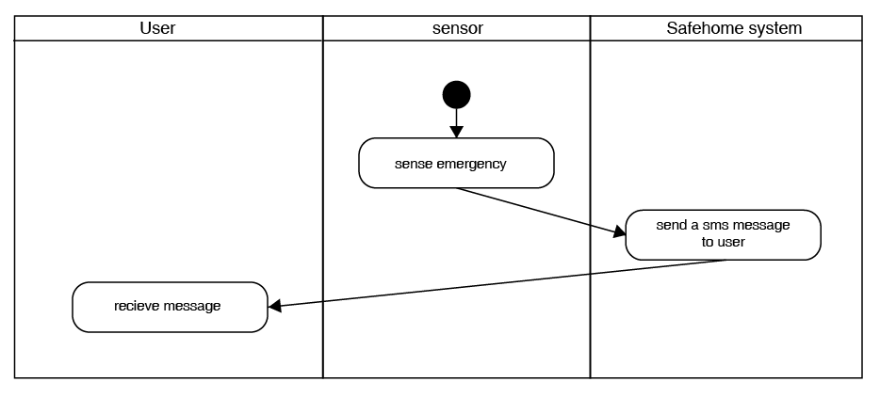
Figure 10 Swimlane diagram for Emergency alarm

Swimlane diagram for surveillance feature

View thumbnails (UC11), View a single camera (UC12), start/stop recording (UC13, UC14), pan/zoom camera (UC17, UC18)
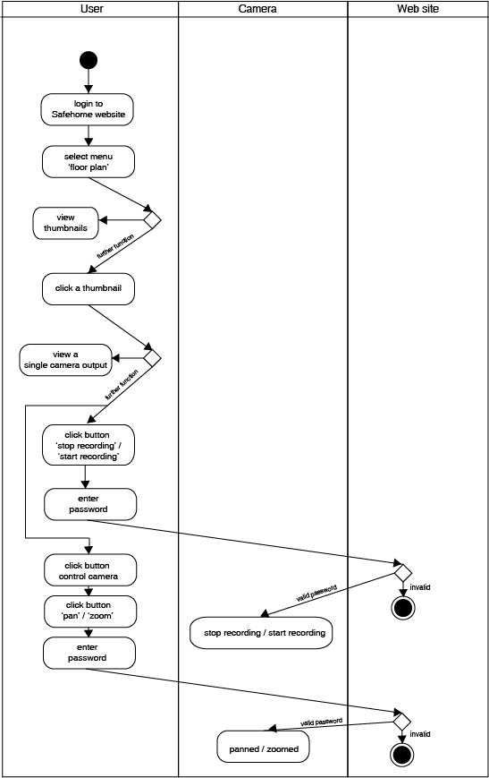
Figure 11 Swimlane diagram for View thumbnails, View a single camera, start/stop recording, pan/zoom camera

Replay/download video (UC15, UC16)
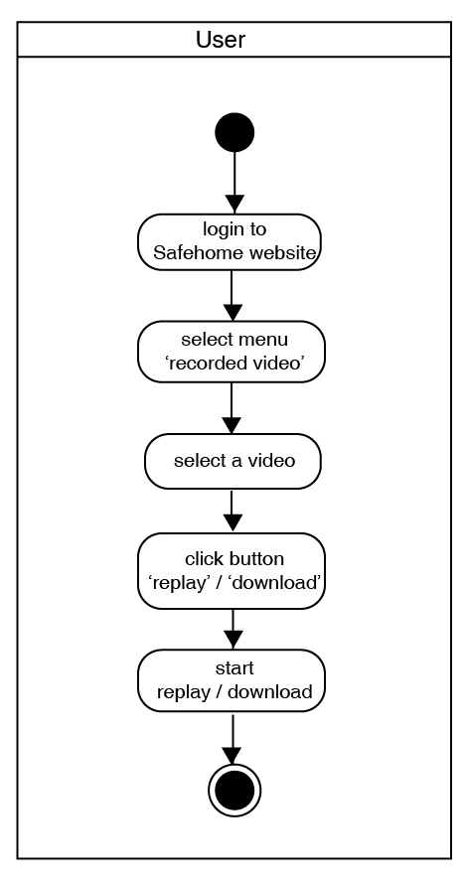
Figure 12 Swimlane diagram for Replay/download video

Swimlane diagram for Safehome Website

Make an account (UC19)
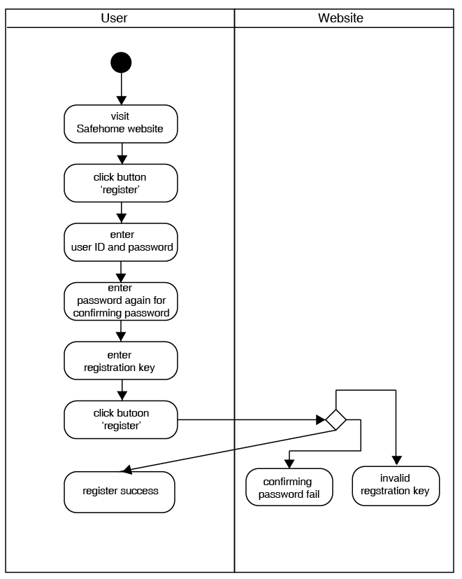
Figure 13 Swimlane diagram for Make an account

Log in to Safehome Website (UC20)
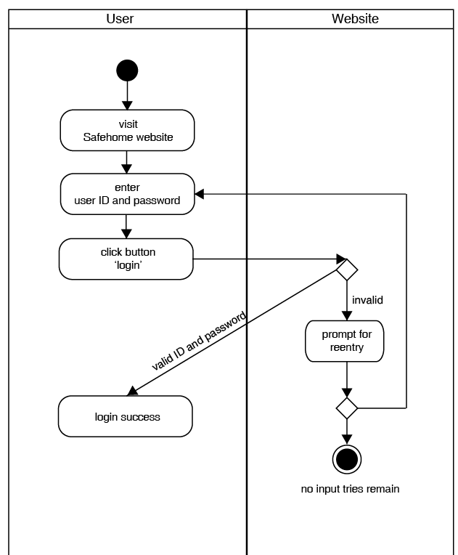
Figure 14 Swimlane diagram for Log in to Safehome Website

Change password (UC21)
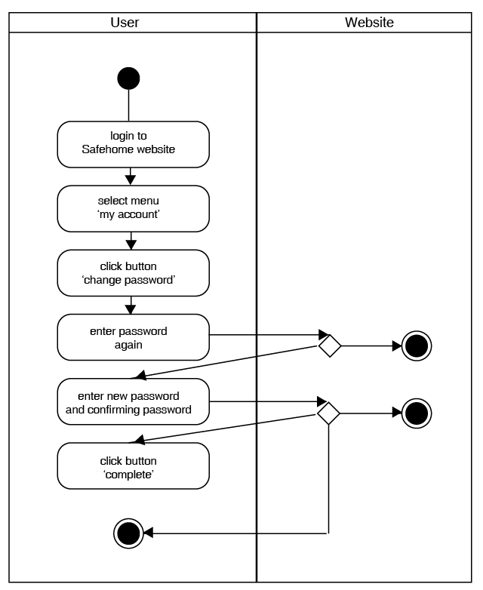
Figure 15 Swimlane diagram for Change password

Appendix

Meeting log

Meeting log 5
Time | 2015-04-25 13:00 ~ 2015-04-25 18:30
Location | N1 building room 403
Participants | Chung Saehun, Koo Yoonpyo
Issues discussed | - Revision of requirement
Next meeting | 2015-04-28 18:00
Issues will be discussed | - Analysis modeling plan  - Revision of SRS

Meeting log 6
Time | 2015-04-28 18:00 ~ 2015-04-28 22:00
Location | N1 building room 403
Participants | Jung Saehun, Koo Yoonpyo
Issues discussed | - Analysis modeling plan  - Revision of SRS
Next meeting | 2015-05-01 23:00
Issues will be discussed | - Analysis modeling plan  - finalize revision of SRS

Meeting log 7
Time | 2015-05-01 23:00 ~ 2015-05-02 01:00
Location | N1 building room 403
Participants | Jung Saehun, Koo Yoonpyo
Issues discussed | - Analysis modeling plan  - revision of SRS
Next meeting | 2015-05-03 22:00
Issues will be discussed | - Assign part of analysis modeling  - revision of SRS

Meeting log 8
Time | 2015-05-03 22:00 ~ 2015-05-03 24:00
Location | N1 building room 403
Participants | Jung Saehun, Koo Yoonpyo
Issues discussed | - Assign part of analysis modeling (use case, use case diagram)  - revision of SRS
Next meeting | 2015-05-05 15:00
Issues will be discussed | - revision of use case and use case diagram  - draw swimlane diagram

Meeting log template
Time | 2015-05-05 15:00 ~ 2015-05-05 21:00
Location | N1 building room 403
Participants | Jung Saehun, Koo Yoonpyo
Issues discussed | - revision of use case and use case diagram  - draw swimlane diagram
Next meeting | 2015-05-06 20:00
Issues will be discussed | - revision of analysis model document

Who did what list
Name | List
Chung Saehun | - Introduction  - Design use case diagram *  - Design swimlane diagram *  - Draw use case diagram  - Draw swimlane diagram
Koo Yoonpyo | - Write all use cases  - Design use case diagram *  - Design swimland diagram *  - Write analysis model document  - Connect hyperlinks

* We did all together

