Homework #1: Due Sep 22 (Tues) 23:59.

- Use the following method printPrimes() for questions a-f below.
- Draw the control flow graph for the printPrimes() method.
(b) Consider test cases t1 = (n = 3) and t2 = (n = 5). Although these tour the same prime paths in printPrimes(), they do not necessarily find the same faults. Design a simple fault that t2 would be more likely to discover than t1 would.
(c) For printPrimes(), find a test case such that the corresponding test path visits the edge that connects the beginning of the while statement to the for statement without going through the body of the while loop.
(d) Enumerate the test requirements for Node Coverage, Edge Coverage, and Prime Path Coverage for the graph for printPrimes().
(e) List test paths that achieve Node Coverage but not Edge Coverage on the graph.
(f) List test paths that achieve Edge Coverage but not Prime Path Coverage on the graph.

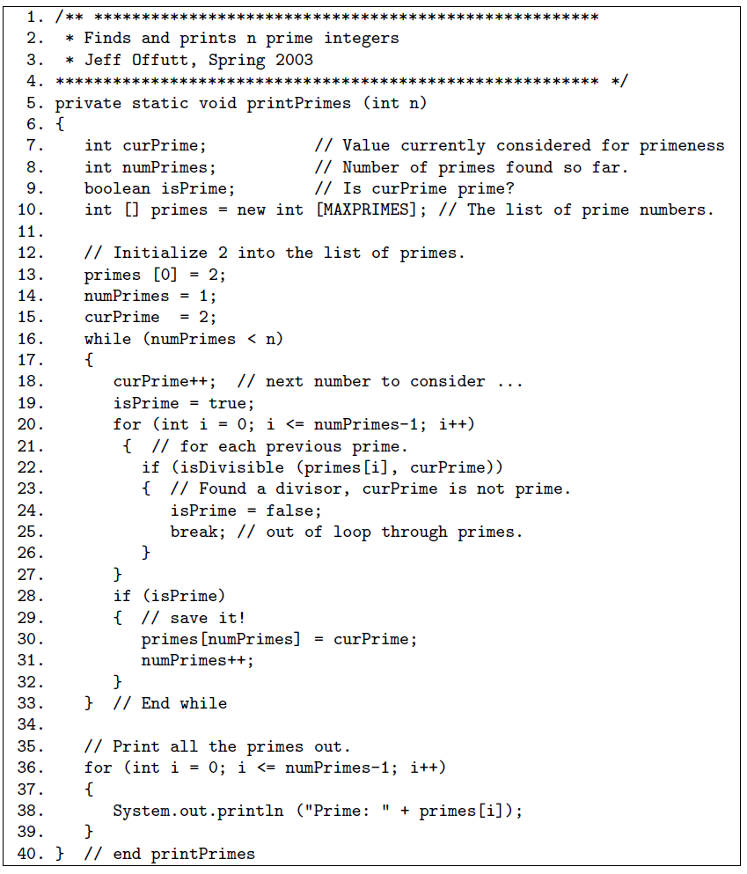

- Use the following method fmtRewrap() for questions a-e below.
(a) Draw the control flow graph for the fmtRewrap() method.
(b) For fmtRewrap(), find a test case such that the corresponding test path visits the edge that connects the beginning of the while statement to the S = new String(SArr) + CR; statement without going through the body of the while loop.
(c) Enumerate the test requirements for Node Coverage, Edge Coverage, and Prime Path Coverage for the graph for fmtRewrap().
(d) List test paths that achieve Node Coverage but not Edge Coverage on the graph.
(e) List test paths that achieve Edge Coverage but not prime Path Coverage on the graph
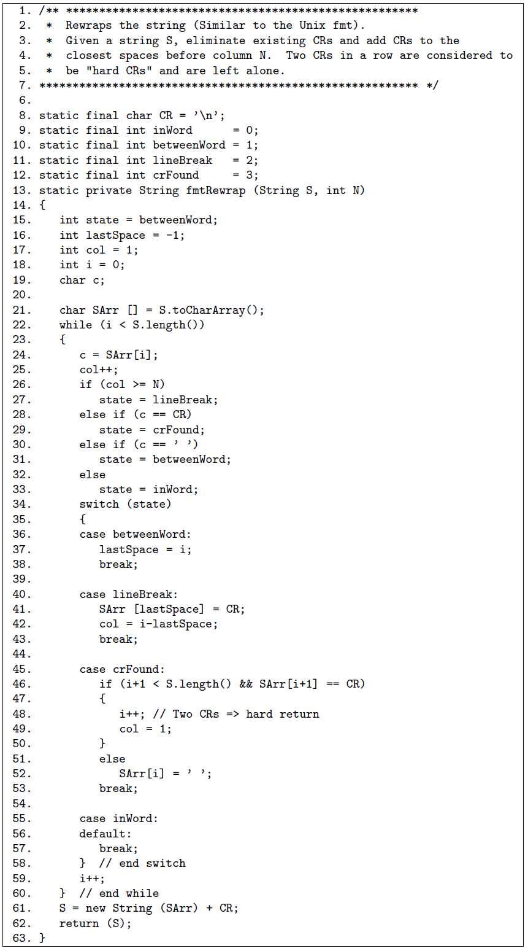

- Below are two graphs, each of which is de_ned by the sets of nodes, initial nodes, final nodes, edges, and defs and uses. Each graph also contains a collection of test paths. Answer the following questions about each graph.

(a) Draw the graph.
(b) List all of the du-paths with respect to x. (Note: Include all du-paths, even those that are subpaths of some other du-path).
(c) For each test path, determine which du-paths that test path tours. For this part of the exercise, you should consider both direct touring and sidetrips. Hint: A table is a convenient format for describing this relationship.
(d) List a minimal test set that satisfies all defs coverage with respect to x. (Direct tours only.) Use the given test paths.
(e) List a minimal test set that satisfies all uses coverage with respect to x. (Direct tours only.) Use the given test paths.
(f) List a minimal test set that satisfies all du-paths coverage with respect to x. (Direct tours only.) Use the given test paths.

