SafeHome Design Guidelines

This document provides guidelines to design and implement the SafeHome system.

- Control Panel

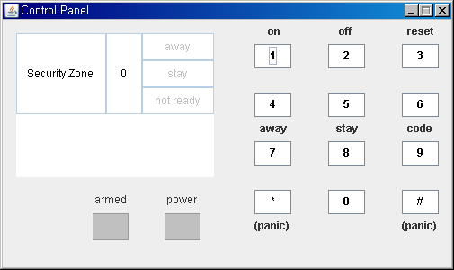

Figure 1 Initial control panel

The control panel is depicted in Figure 1. It displays two lines long text message on LCD, armed and power status on LED, the current security zone number, and away, stay, or not ready status. The panel has 12 buttons. Buttons ‘1’, ‘2’, ‘3’, ‘7’, ‘8’, ‘9’, ‘*’ and ‘#’ have labels showing their functionality. For example, the button ‘1’ is used to input numeric number 1 when a home owner enters a password. But, the button ‘1’ is also used to turn on the SafeHome system, as it is labeled with “on”. See Table 1 for more detail.

Table 1. Functionalities assigned to the buttons

Name | Description
on | Turn on SafeHome from the standby mode
off | Switch SafeHome to the standby mode
reset | Re-initialize SafeHome
away | Enable current security zone. Sensors in the zone are activated
stay | Disable current security zone. Sensors in the zone are deactivated
code | Change the control panel password
panic | Make a emergency call

A user can turn on and off the SafeHome system through the panel. When the system is power on, power LED is green. A user can see which security zone is enabled through the control panel. Security zones are defined through a web interface. In the away mode, all sensors defined in the current security zone are enabled and armed LED turned on red (see Figure 2). In order for the user to open a main entrance door of the house and leave, the door sensor located at the main entrance gate of the house should be activated 30 seconds after a user pressed the “away” button. If the system is not ready (i.e. a window or a door is open) when the user presses the away button, a ‘not ready’ message is displayed on the LCD display, and a user must physically close windows/doors so that the ‘not ready’ message disappears (Figure 3). A user can disable sensors and cameras by pressing ‘stay’ button.

A security zone consists of set of win/door sensors and motion detectors. SafeHome should have at least one security zone and can activate only one security zone at a time. Each security zone can be overlapped, so a sensor can be included in two or more security zones.

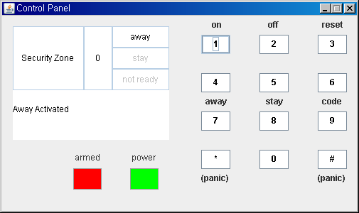

Figure 2 Away status

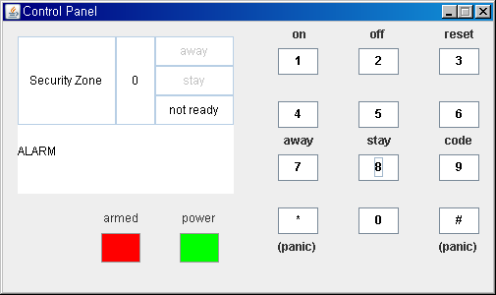

Figure 3 The system should not be changed to away mode when the system is not ready.

For security, SafeHome has three types of passwords: a control panel password, web interface password, and camera password. Control panel password is required to operate SafeHome through the control panel. Web interface password is required to login the web interface for the SafeHome system. A camera password is set for each camera.

Power off, reset, away, stay, and code functions through the control panel require a control panel password. Your system should keep control panel password. A user can change only the control panel password thought the panel. Other password can be changed only through the web interface.

Figure 4. shows a simplified state diagram for SafeHome security function (for more details, see SEPA p. 231). A state diagram for the control panel is based on a state diagram for security function and specifies the transitions triggered by button input events.

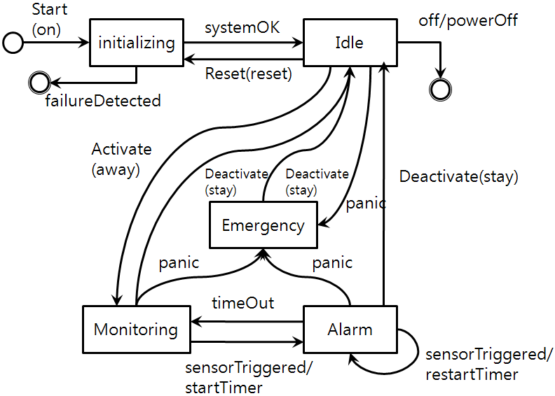

Figure 4 Simplified state diagram for the SafeHome security functions

Figure 5 shows a state diagram related to ‘power on’. Each transition related to button input in Figure 4 should be specified in more detail to handle button input events.

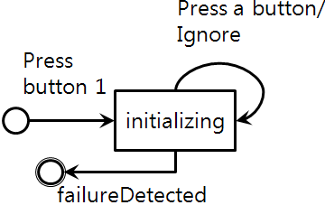

Figure 5 Press 'on' button event

Figure 6 shows password key press mechanisms. This mechanism use 4-digits fixed length passwords (Figure 7). # and * are also allowed in a password. The password key press mechanisms check timeout. If a user does not proceed with input within 5 seconds, the panel goes to a starting state.

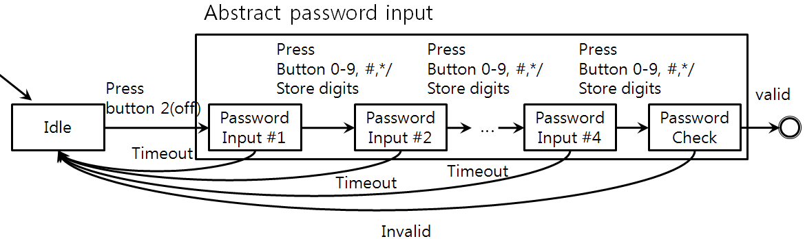

Figure 6 Password key press mechanism.

Figure 7~11 shows how the control panel state is changed by button inputs.
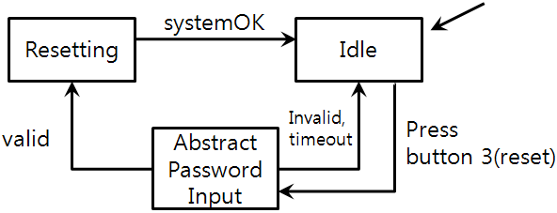

Figure 7 Press 'reset' button event

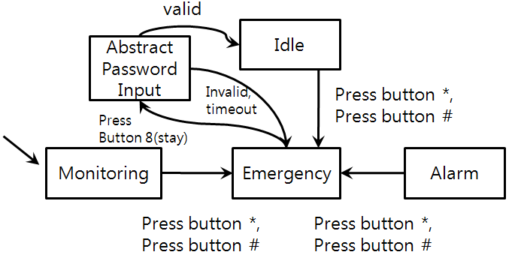

Figure 8 Press 'panic' button event
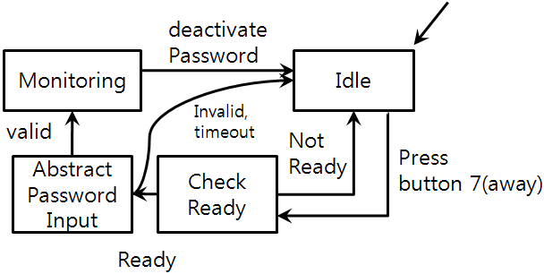

Figure 9 Press 'away' button event

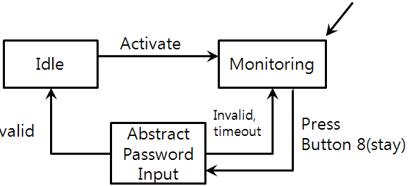

Figure 10 Press 'stay' button

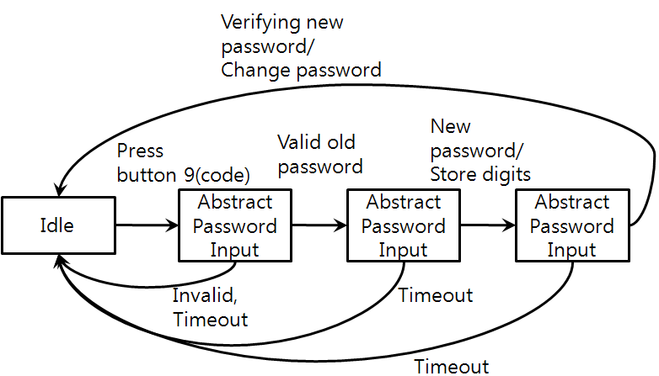

Figure 11 Press 'code' button

In the idle state, button 1(on), 4, 5, 6, 8(stay), 0 inputs are ignored. Similarly, button 1(on), 3(reset), 4, 5, 6, 7(away), 9(code), 0 are ignored in the monitoring state and button 1(on), 2(off), 3(reset), 4, 5, 6, 7(away), 9(code), *(panic), #(panic), 0 are ignored in the alarm state. If a user presses a stay button in alarm state, the panel displays ‘not ready’ on LCD.

- Web Interface

The SafeHome system provides a full control to the SafeHome system via a secure web interface. To access the SafeHome web interface, a user should have an ID and two level passwords, a panel password and a web password (Figure 12). A user can change all passwords (including camera passwords) through ‘Configure’ -> ‘Configure System’ menu.

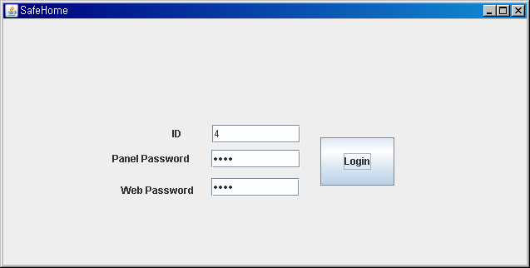

Figure 12 Two level passwords are required to access the web interface

The web interface should show a floor plan to monitor current status in a view (Figure 13). For simplicity of design and implementation, you can assume that the floor plan is static and not reconfigurable (SafeHome company installs SafeHome and configures a floor plan for a home user). A user can pick a camera to view or set sensors(enabled/disabled) by clicking a camera or a sensor.

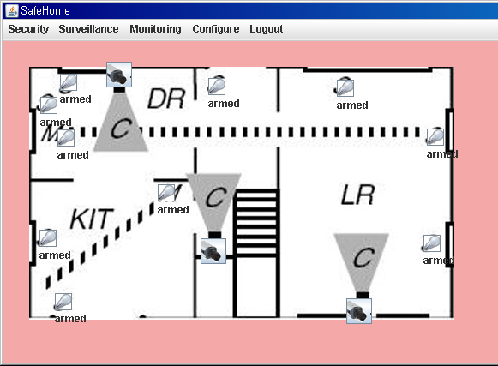

Figure 13 A floor plan for monitoring in a view

One important feature provided via the web interface is camera monitoring. A user can view thumbnails of cameras through ‘Surveillance’ menu (Figure 14) or pick a specific camera in a floor plan (Figure 15). A user can view a camera by clicking a camera in a floor plan or clicking a thumbnail in a thumbnail view. Each camera should be protected by its own camera password. This demo program misses it. Protected camera view should not be seen unless a user input a valid password. If a user has input valid camera passwords to a camera, that camera view can be seen in a thumbnail view in camera session timeout.

A user can change a camera password through camera video view. You have to add ‘change password’ button on the view and implement camera password. Camera recording is not supported in this version of SafeHome.

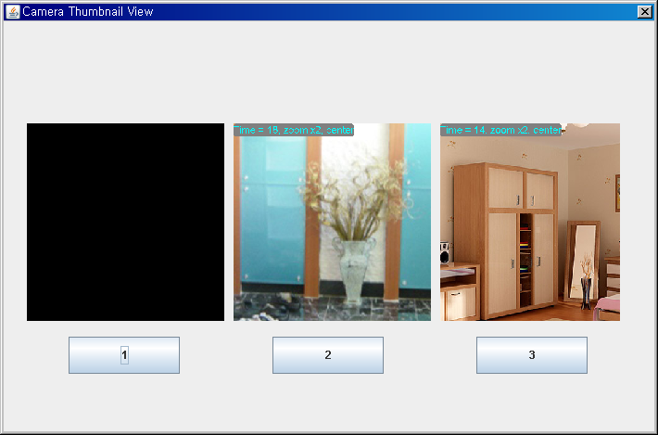

Figure 14 Thumbnails of cameras. Camera 1 is protected by a camera password

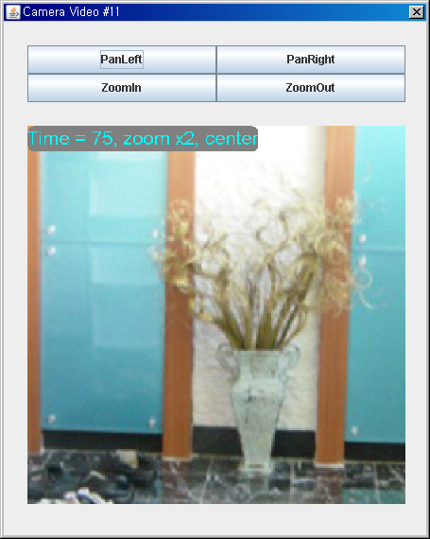
Figure 15 A camera view. Turn angle left/right and Zoom in/out are supported

Another important feature is to define security zones. A user can create and define security zones (Figure 17) and activate a security zone though ‘Configure’ -> ‘Configure Sensor’ menu(Figure 16, 18). A user selects sensors to be included in the security zone by clicking a sensor in a floor plan. Security zones can be configured only when the SafeHome system is idle.

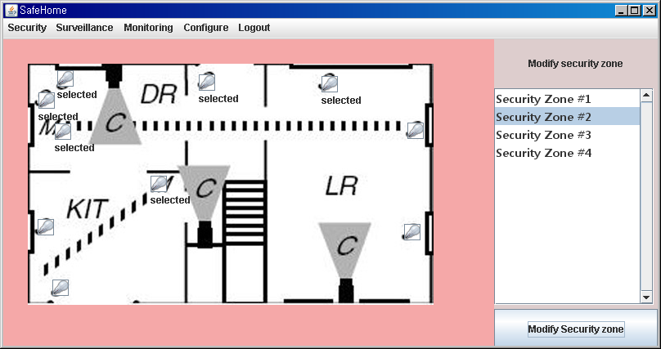

Figure 16 Example of a security zone. 'selected' sensors are activated on an away mode

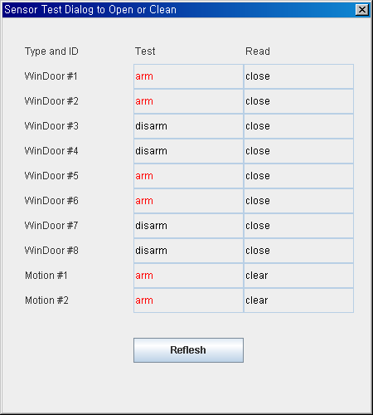

Figure 17 Only sensors in a security zone #2 are enabled.

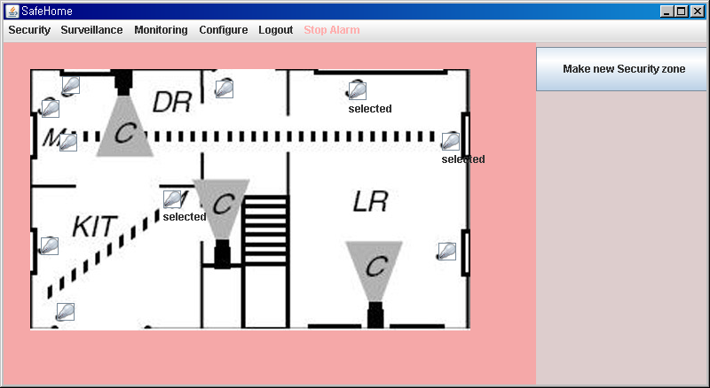

Figure 18 Create a new security zone

