CS550 Intro. to SE Quiz2
Mar 16, 2008
Name:
Student ID:
I hereby declare that I do not conduct any action against academic honesty. I fully understand penalty for any kind of dishonest action and take full responsibility of it.
Signature

1. Is it possible to develop an effective analysis model without developing all four elements shown in the following figure? Explain
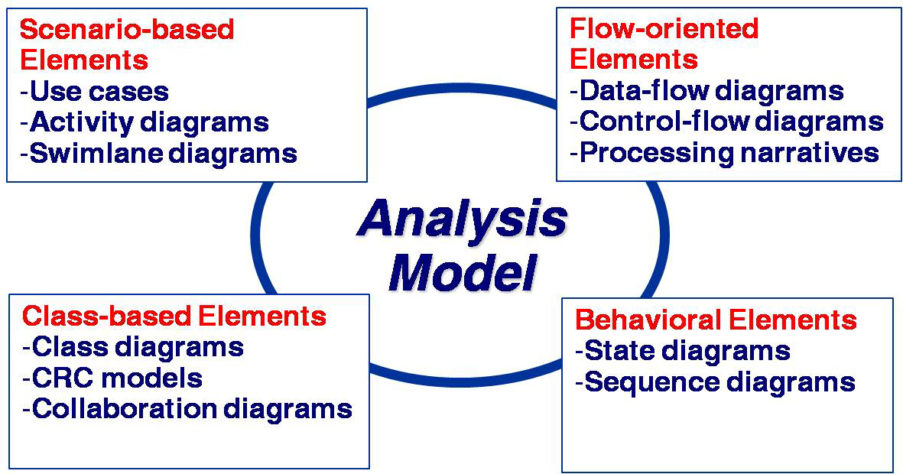

A: It is possible to develop an effective analysis model without developing all four elements shown in Figure 8-3. However, each element presents a different view of the problem to be solved, and therefore provides the ability to see potential problems, inconsistencies or omissions more clearly. In addition, if all four elements of the analysis model are developed, the transition to design is simplified.

2. Is it possible to begin coding immediately after an analysis model has been created? Explain your answer and then argue the counterpoint (e.g. negative effects)
A: The analysis model will serve as the basis for design and construction of the domain objects. It is possible to begin coding after the objects and attributes are defined, and relationships are known. However, the design will suffer as a result because explicit architectural design will not have been considered; interfaces will have been developed in a haphazard manner, and global data structures will not have been explicitly designed

3. An analysis rule of thumb is that the model “should focus on requirements that are visible within the problem or business domain.” What types of requirements are not visible in these domains? Provide a few examples.
A: Many infrastructure requirements are not visible in the problem or business domain. For example, what functions are required to manage global data, what functions are required to implement network communication; what functions are required to implement a user interface

